Kenya medical training college
Machakos campus
C.O.T.M September class
Casting and Traction Technique
Below Elbow Cast/ Thumb Spica Cast

Below elbow cast

Introduction
- The short arm cast is also known as the below-elbow cast. This is a frequently used circumferential immobilization cast of the forearm and wrist made of either synthetic material or plaster of Paris, used as a treatment for fractures and soft tissue injuries of the forearm
Indication
- the forearm distal forearm fractures,
- carpal and wrist injuries,
- pediatric buckle fracture
- immobilization of after surgery.
Required materials
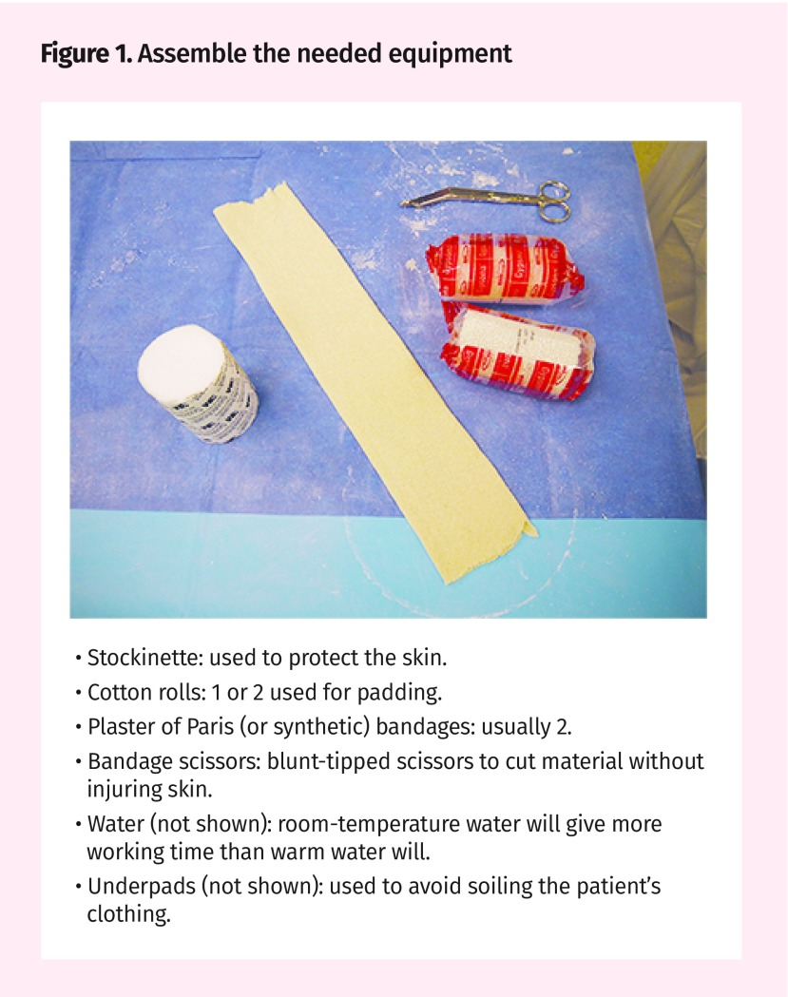

Applying the cast: • The first layer of padding should wrap around the limb in two complete rotations prior to advancing the roll, creating 2 layers of padding at the proximal most aspect. • Commence plaster wrapping. Start distally to the injury ensuring not to breech the limits of the soft ban wrap. • Unroll the plaster of Paris rolls over the limb, taking care not to pull excessive tension on the roll. • The first layer of plaster should complete two full rotations directly over each other prior to advancing the roll down the limb. • Continue to advance the plaster roll down the limb, wrapping 66% to create 3 layers of cast. • Upon reaching the hand, ensure casting terminates prior to the distal palmar crease. • Advance the cast between the thumb and fore-finger by creating a curved cut and continue. • 2 Layers of plaster between thumb and fore finger are sufficient. • Upon completing the first roll of plaster fold the soft ban edges back over the plaster layer to create an edge at the distal and proximal aspects. • Repeat the plaster roll wrap again starting proximally, capturing the rolled back soft ban edges, and advancing down the limb creating 6-8 layers of plaster. • Laminate plaster layers by rubbing plaster between flat palms. • As the plaster hardens and dries, it warms up. • Place the drying cast on a pillow and allow to set for 20 minutes prior to application of sling.
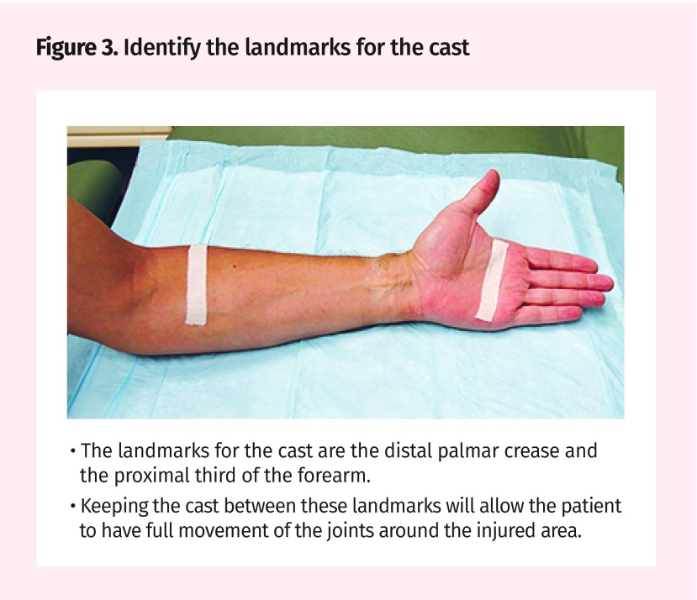
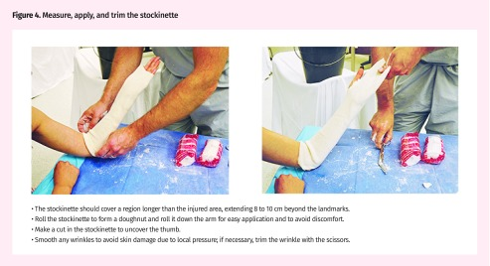
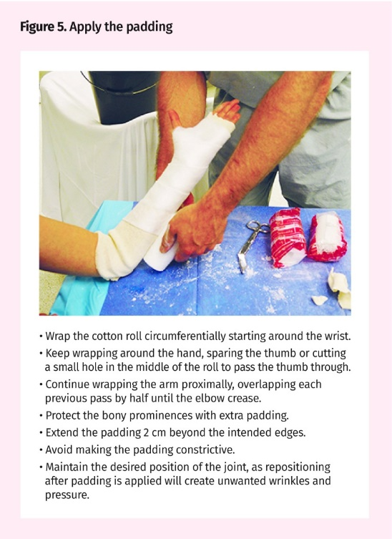
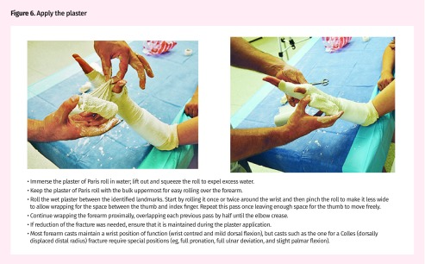
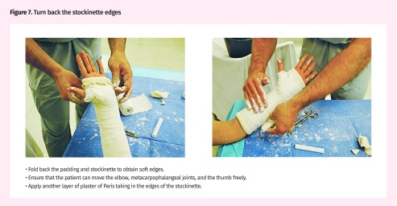
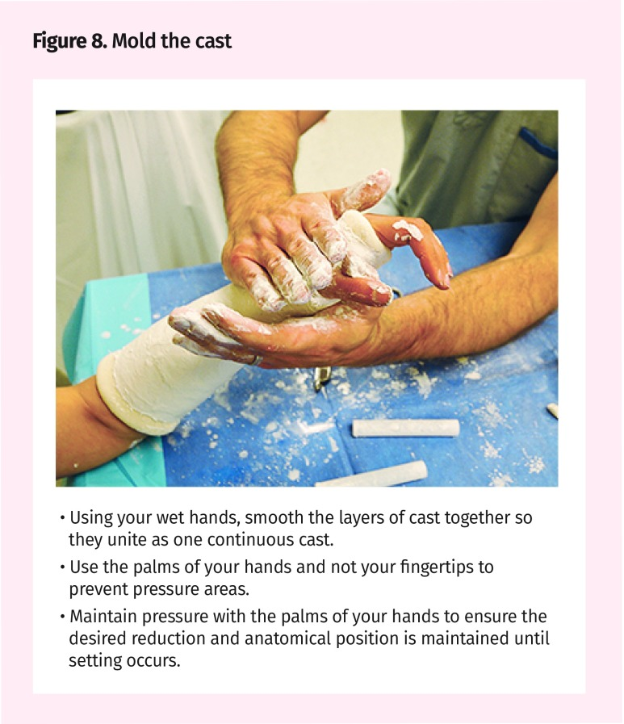
Complication
- stiffness,
- pressure sores
- compartment syndrome
- muscle atrophy
- Neurapraxia
- Ischemic injury
Contraindication
- Open fractures
- Excessive swelling
Injury to radial nerve
Injury to median nerve
Thumb Spica cast
Introduction
This casts can go from just below the elbow to the knuckles but include the thumb or from the wrist and up the thumb

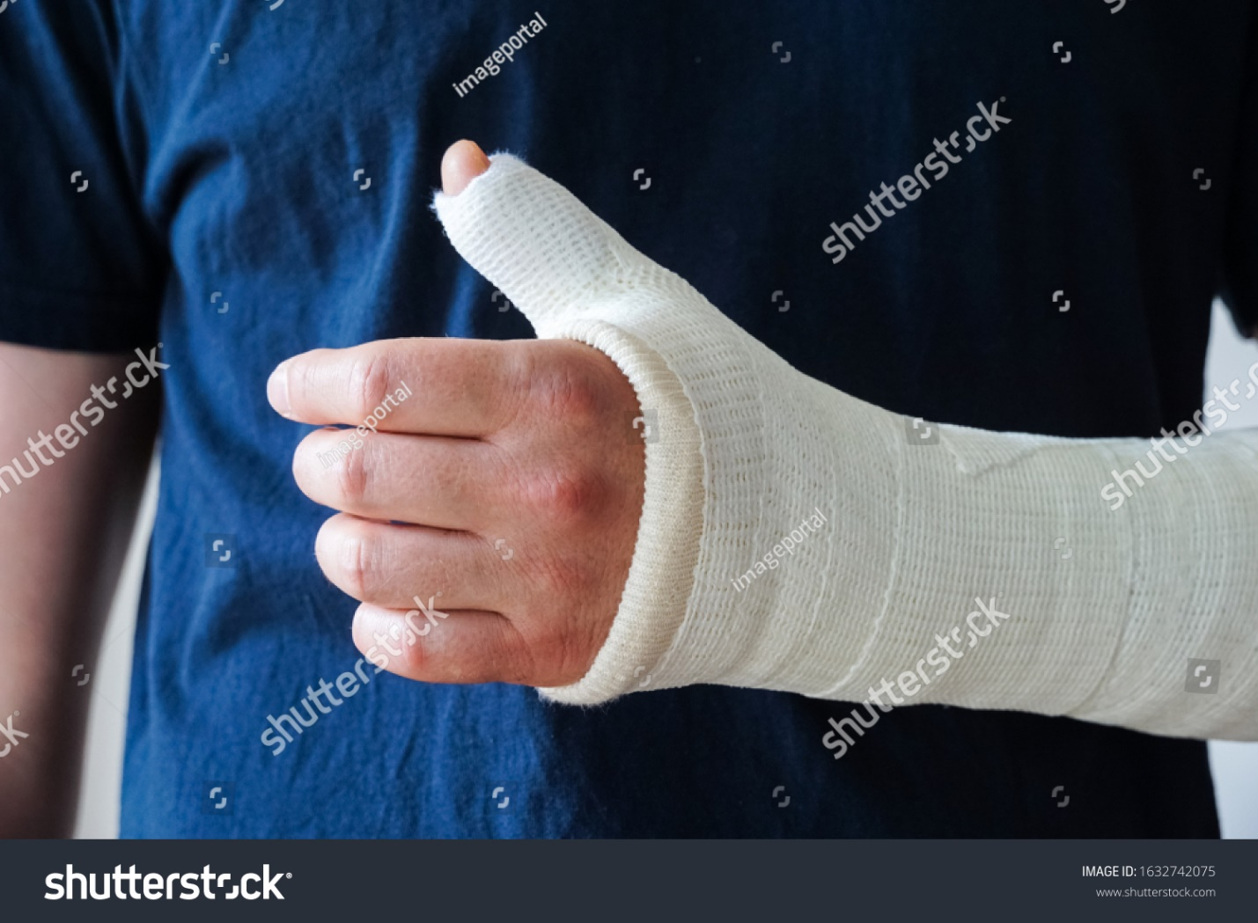

Indication
- Scaphoid injuries.
- Lunate injuries.
- First metacarpal fractures.
- Injury to the ulnar collateral ligament (UCL)
- Positioning for de Quervain tenosynovitis.
Complication
- stiffness,
- pressure sores
- compartment syndrome 5p
pain, pallor (pale skin tone), paresthesia (numbness feeling), pulselessness (faint pulse) and paralysis (weakness with movements)

- muscle atrophy
Contraindication
Open fracture
Injury to median nerve
Excessive swelling

